Year 8 Worksheet Index Law 3 and 4
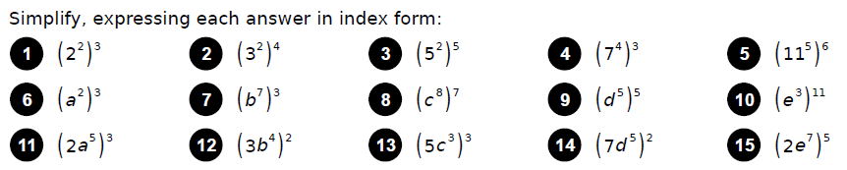
1  2  3  4  5  6  7  8 | 9  10  11  12  13  14  15

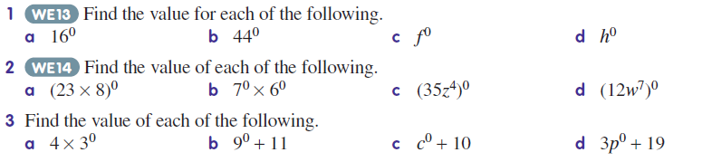

1.  A  B  C  D | 2.  A  B  C  D | 3.  A  B  C  D

